Synopsis
On
GROCERY WEBPAGE
Submitted in partial fulfillment of the requirement
For the award of the degree of
B.TECH
In
Computer Science & Engineering (Data Science)
5th Semester (3rd Year)
Submitted By
SANDEEP KUMAR ( 2000681540035 )
DHAIRYA RAJPUT ( 2000681540014 )
Under the guidance
Mr. Suraj Bhatnagar, Mr.Rohit Aggarwal & Mr. Babu Kumar

Computer Science & Engineering (Data Science)

Meerut Institute of Engineering & Technology, Meerut

INDEX

Sr No. | Topic | Page No.
1. | Introduction | 3
2. | Objectives & Scope | 4
3. | Methodology | 5
4. | Tools & Technologies | 7
5. | References | 8

FIGURES

Sr No. | Figure Name | Page No. | Fig No.
1. | Use Cases of Mygrocery.com webpage | 6 | 1.1

INTRODUCTION

Online Grocery Shopping is the norm these days. In fast pace of time today, everyone is squeezed for time, people want to easily shopping without going to shop. In this grocery webpage, it provides many facilities like home delivery at the time, debit card/credit card/net banking/cash on delivery payments systems, add cart or remove etc. Purpose of Online Grocery Shopping system is to allow customer to shop virtually using internet. Computerization of online store will increase the ease, efficiency and reduce the chances of manual errors. With the popularity of PCs, and Mobiles easy access to Internet and World Wide Web (WWW), Internet is increasingly used by consumers & vendors as a channel for shopping, payment & other operations.

Customers will be able to browse and search products under different categories. Selected products or items selected for purchase would be added into the virtual shopping cart which can be managed separately by customer. It can be examined at any time by customer for selected products, their quantity & price. These would be main functionalities apart from some usual operations such as login, logout, create new account etc.

OBJECTIVES & SCOPE

- The main purpose of Online Grocery Shopping system is to allow customer to shop virtually using internet and get the things they want as soon as possible.

- There would be a lot of scope to improve this project, since basic functionality would be provided.

- Some of the modules to improve are admin part such as personalized recommendations, discount & offer management. For customers, notification & messaging etc. can be applied.

- Basically the main intention is to work on the Back End .These can be developed to make it more effective.

METHODOLOGY

Planning for project development :
- Research : Explore about the different types & qualities of grocery items like fruits, vegetables, oils, etc.

- Pseudo : Writing pseudo for every page

- Algorithm : Making algorithm for every page

- Prototype : Drafted a rough format of web project on papers and then implemented same using HTML, CSS, JS.

- Images : Selected set of suitable photos from internet and the resize them according to the requirements.

- Design : Selecting better picture for creative view of the webpage.

Possible use cases are mentioned in the below diagram which will illustrate the scope of solution which we intend to develop :
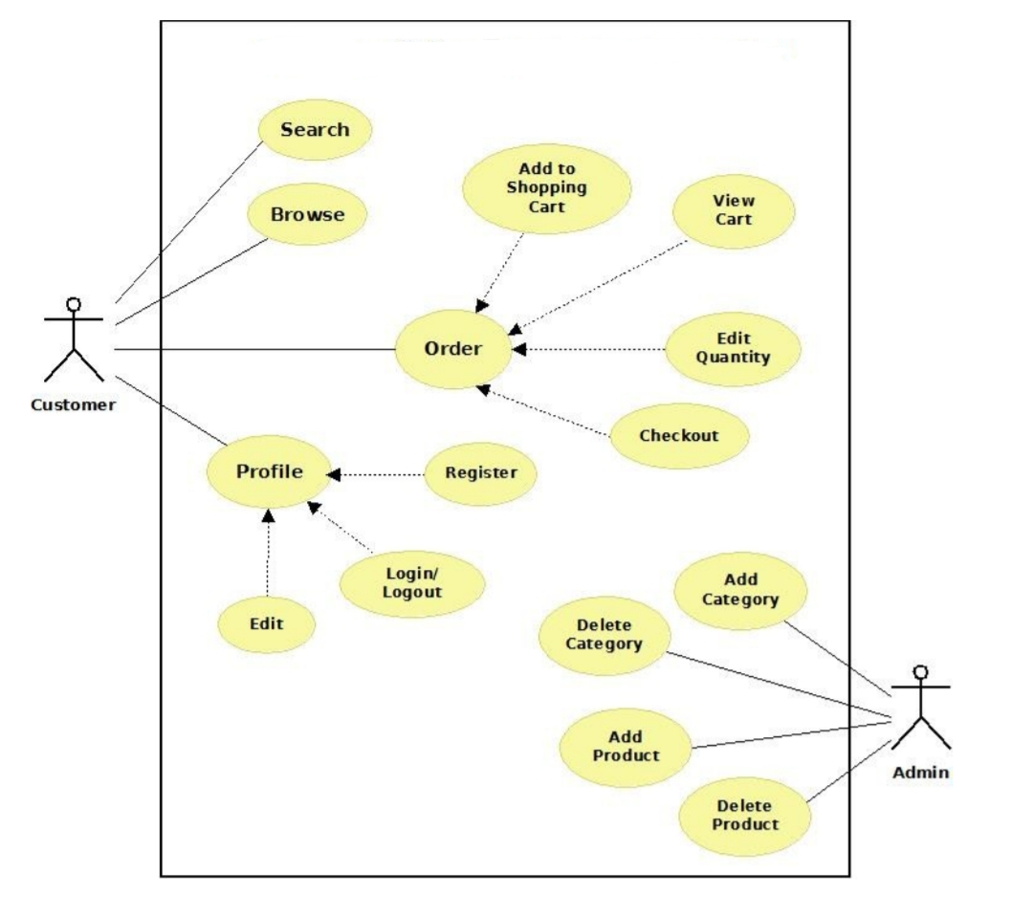
Fig 1.1 Use Cases Of Mygrocery.com webpage

TOOLS & TECHNOLOGIES
( Software/Hardware Requirements )

- Software
- HTML
- CSS
- Java Script
- Web Browser
- Window 7 or higher

- Hardware
- 2GB RAM or higher
- Active Internet Connection

SCREEN-SHOTS: Home Page

Registration Page

Login Form

Product Categories Page

About Us Page

Review Page

Contact Page

View Cart Page

REFERENCES

- www.resizepixel.com ( for resizing photos )
- www.remove.bg ( for removing background of photos)
- www.w3schools.com

